**Deployment Steps of custom widget**

1. Unzip the **Customwidgets.zip**. You will find following folders

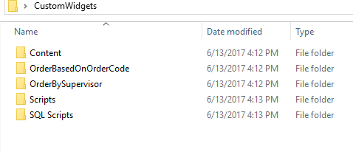

1. Copy Paste the **OderBasedOnOrderCode** and **OrderBySupervisor** folder to your filebound site’s **widget** folder.
2. Create the **same name** widgets from filebound setting see below image.

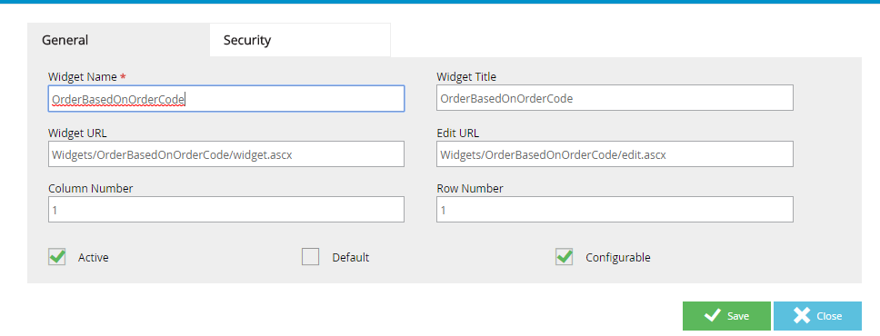

.

1. You will find Content/**Customwidgets** folder please copy paste this one to filebound site’s **Content** folder.
2. You will find Scripts/**Customwidgets** folder please copy paste this one to filebound site’s **Scripts** folder.
3. Run the Script files to the database from SQL Scripts folder.